**DAILY ONLINE ACTIVITIES SUMMARY**

|  |  |  |  |  |  |  |  |  |
| --- | --- | --- | --- | --- | --- | --- | --- | --- |
| **Date:** | **02/06/2020** | | | | | **Name:** | **NAIPUNYA VINOD NAIK** | |
| **Sem & Sec** | **IV SEM & A SECTION** | | | | | **USN:** | **4AL18CS050** | |
| **Online Test Summary** | | | | | | | | |
| **Subject** | | **NO TEST CONDUCTED** | | | | | | |
| **Max. Marks** | | **NIL** | | **Score** | | | **NIL** | |
| **Certification Course Summary** | | | | | | | | |
| **Course** | **1)INTRODUCTION TO CYBERSECURITY**  **2) RPA** | | | | | | | |
| **Certificate Provider** | | | **1)GREAT LEARNING ACADEMY**  **2)RPA** | | **Duration** | | | **1)7 HRS**  **2)3 HRS** |
| **Coding Challenges** | | | | | | | | |
| **Problem Statement:1)** Write a program in java, an array of integer data to be initialized. During the initialization, if a user enters a value other than integer value, then it will throw InputMismatchException exception. On the occurrence of such an exception, your program should print “You entered bad data.” If there is no such exception it will print the total sum of the array.  2) [Given an array of positive integers. Write a C Program to find inversion count of array.](https://github.com/orgs/alvas-education-foundation/teams/2nd-year/discussions/95)  3)   [Write a Java program to find Perfect Sum Problem](https://github.com/orgs/alvas-education-foundation/teams/2nd-year/discussions/94).  Top of Form  Bottom of Form    Top of Form  Bottom of Form    [Write a Java program to find Perfect Sum Problem](https://github.com/orgs/alvas-education-foundation/teams/2nd-year/discussions/94)  Top of Form  Bottom of Form  Top of Form  Bottom of Form    [Write a Java program to find Perfect Sum Problem](https://github.com/orgs/alvas-education-foundation/teams/2nd-year/discussions/94) | | | | | | | | |
| **Status: EXECUTED** | | | | | | | | |
| **Uploaded the report in Github** | | | | | **YES** | | | |
| **If yes Repository name** | | | | | <https://github.com/naipunya-naik/lockdown-coding/blob/master/C%20CODING/inversioncount_02-06-2020.c>  <https://github.com/naipunya-naik/lockdown-coding/blob/master/JAVA%20CODING/SumArray_02-06-2020.java>  <https://github.com/naipunya-naik/lockdown-coding/blob/master/JAVA%20CODING/arrayinput_02-06-2020.java> | | | |
| **Uploaded the report in slack** | | | | | **YES** | | | |

Online Test Details: (Attach the snapshot and briefly write the report for the same).

NO TEST CONDUCTED.

Certification Course Details: (Attach the snapshot and briefly write the report for the same).

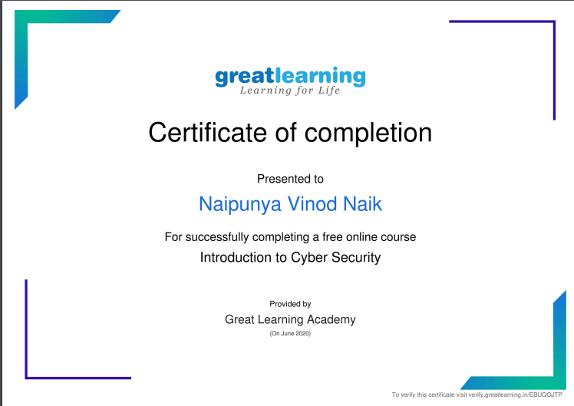

TOPICS LEARNT THROUGHOUT THE COURSE:-

* BLOCKCHAIN IN CYBERSECURITY
* CAREER AND INDUSTRY LANDSCAPE
* GOVERNANCE AND RISK
* INTRODUCTION TO CRYPTOGRAPHY
* SECURE SYSTEM DESIGN
* THREATS AND VULNERABILITIES
* WHAT IS CYBERSECURITY?

2)

TODAY ON 02 JUNE 2020, I COMPLETED THE 3 HRS COURSE OF STEP INTO ROBOTIC PROCESS AUTOMATION.

Coding Challenges Details: (Attach the snapshot and briefly write the report for the same)

1) [Write a Java program to find Perfect Sum Problem](https://github.com/orgs/alvas-education-foundation/teams/2nd-year/discussions/94).

|  |
| --- |
| Given an array arr[] of integers and an integer K, the task is to print all subsets of the given array with the sum equal to the given target K.  **Examples:**  **Input:** arr[] = {5, 10, 12, 13, 15, 18}, K = 30 **Output:** {12, 18}, {5, 12, 13}, {5, 10, 15} **Explanation:** Subsets with sum 30 are: 12 + 18 = 30 5 + 12 + 13 = 30 5 + 10 + 15 = 30  Input: arr[] = {1, 2, 3, 4}, K = 5 Output: {2, 3}, {1, 4} |

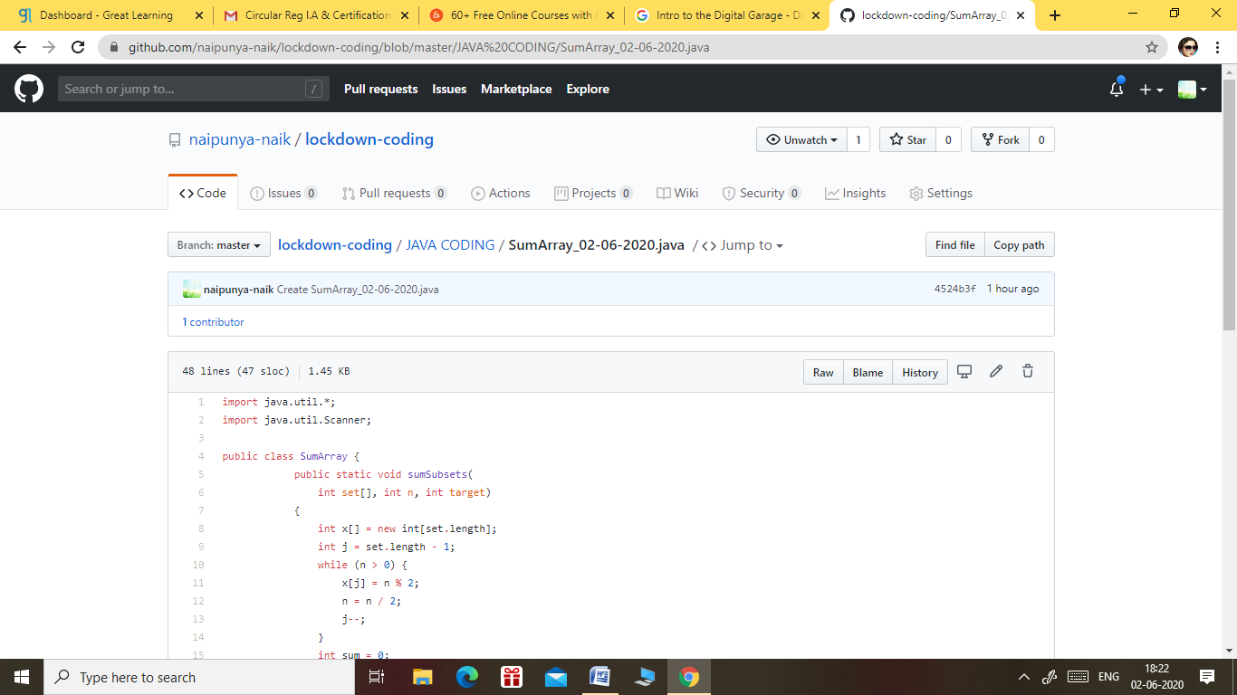

GITHUB REPOSITORY LINK:-

<https://github.com/naipunya-naik/lockdown-coding/blob/master/JAVA%20CODING/SumArray_02-06-2020.java>

2) [Given an array of positive integers. Write a C Program to find inversion count of array.](https://github.com/orgs/alvas-education-foundation/teams/2nd-year/discussions/95)

Top of Form

Bottom of Form

|  |
| --- |
| **Inversion Count:** For an array, inversion count indicates how far (or close) the array is from being sorted. If array is already sorted then inversion count is 0. If array is sorted in reverse order that inversion count is the maximum. Formally, two elements a[i] and a[j] form an inversion if a[i] > a[j] and i < j. **Input:** The first line of input contains an integer T denoting the number of test cases. The first line of each test case is N, the size of array. The second line of each test case contains N elements. **Output:** Print the inversion count of array. **Constraints:** 1 ≤ T ≤ 100 1 ≤ N ≤ 107 1 ≤ C ≤ 1018 **Example: Input:** 1 5 2 4 1 3 5 Output: 3 **Explanation: Testcase 1:** The sequence 2, 4, 1, 3, 5 has three inversions (2, 1), (4, 1), (4, 3). |

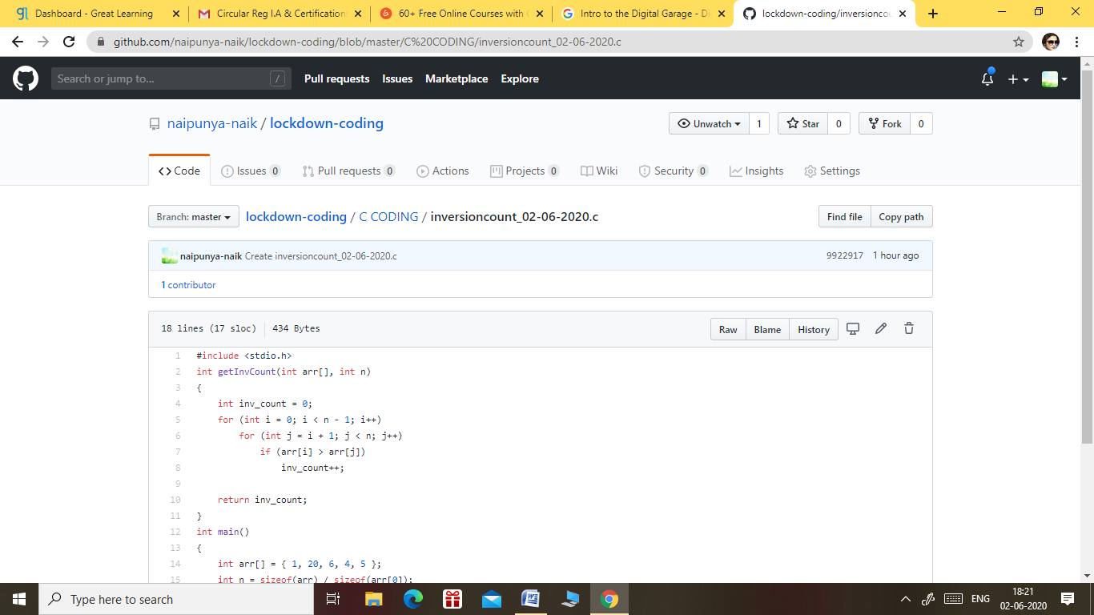

GITHUB REPOSITORY LINK:-

<https://github.com/naipunya-naik/lockdown-coding/blob/master/C%20CODING/inversioncount_02-06-2020.c>

3) Write a program in java, an array of integer data to be initialized. During the initialization, if a user enters a value other than integer value, then it will throw InputMismatchException exception. On the occurrence of such an exception, your program should print “You entered bad data.” If there is no such exception it will print the total sum of the array.

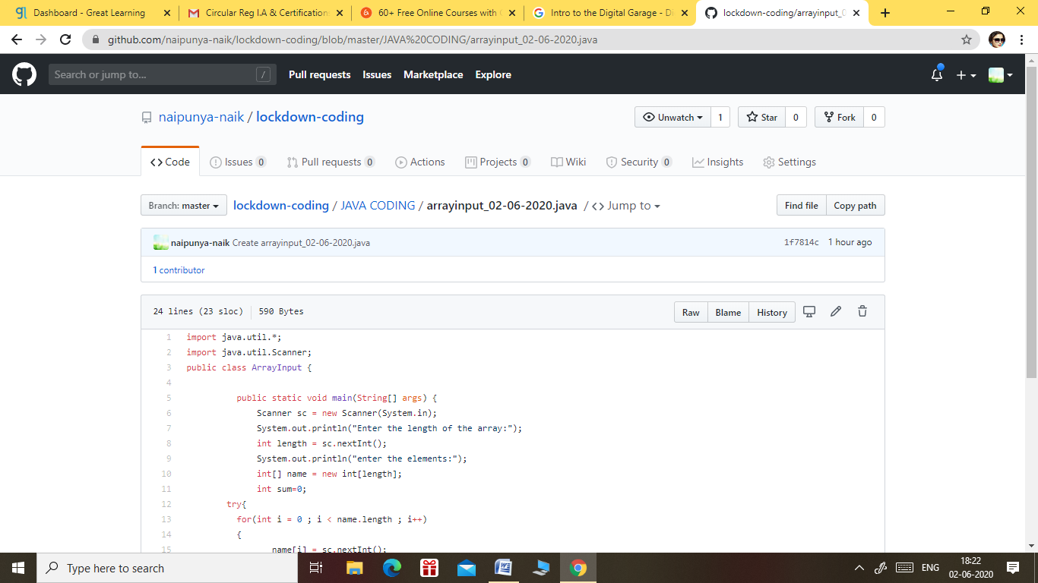

GITHUB REPOSITORY LINK:-

<https://github.com/naipunya-naik/lockdown-coding/blob/master/JAVA%20CODING/arrayinput_02-06-2020.java>